DBMS Practical No.: 15

**Name: yash ajay magar**

**Experiment No. 5:** Execute DCL commands to control the access to data using SQL

Practical related questions:

Emp (Emp_no as primary key, E_name, Dept_no, Dept_name, name, Job_id, Salary) and Dept (Dept_no as primary key, emp_no foreign key, deptname, location)

1. Display the information of the tables using SELECT command.

2. Execute the SQL queries using SELECT, WHERE, GROUP BY clause.

3. Execute the SQL queries using SELECT, WHERE, GROUP BY and HAVING clause.

4. Execute the SQL queries using SELECT, WHERE, ORDER BY clause.

5. Write the advantages of using the Order By clause.

1. Display the information of the tables using SELECT command.

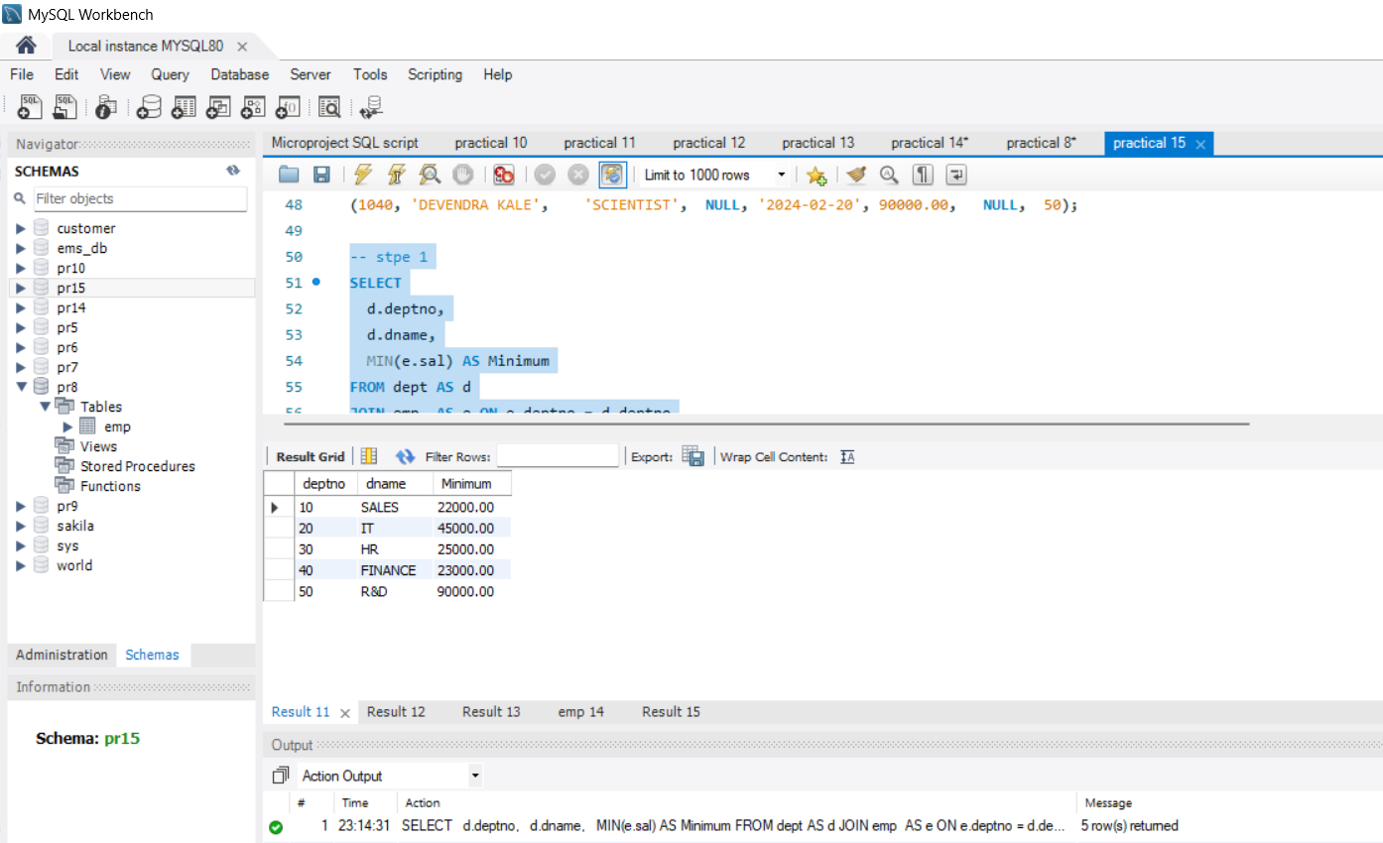

2. Execute the SQL queries using SELECT, WHERE, GROUP BY clause.

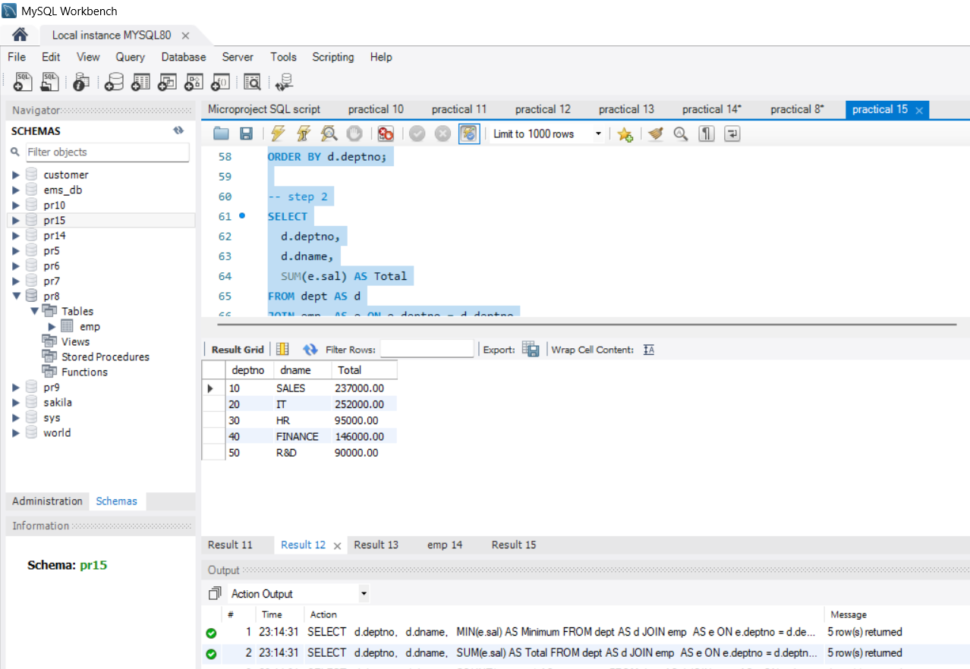

3. Execute the SQL queries using SELECT, WHERE, GROUP BY and HAVING clause.

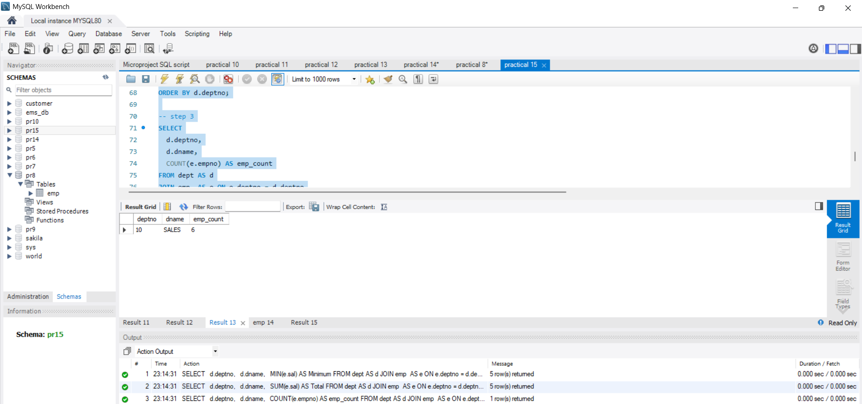

4. Execute the SQL queries using SELECT, WHERE, ORDER BY clause.

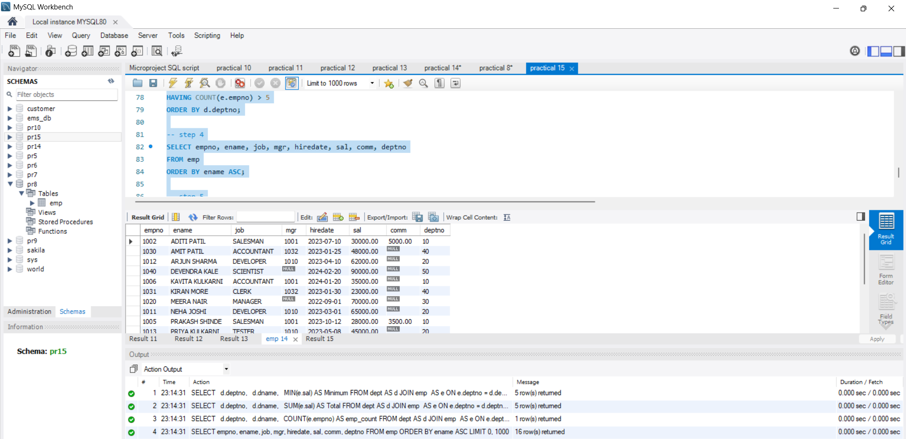

5. Write the advantages of using the Order By clause.

